**World Quant University**

**Professor: Douglas Kelly**

**Algorithms I**

Nikolas Lippmann Pareschi - [nikolaslippmann@gmail.com](mailto:nikolaslippmann@gmail.com)

**MINI PROJECT 2: FAST FOURIER TRANSFORM ALGORITHM**

I chose to investigate Natural Gas prices because there are some papers and finance literature claiming evidence of seasonal price patterns related to a decrease in inventories in winter and a increase in summer. In fact, it is very interesting, what happens is the inverse, **price usually rise in summer and falls in winter**. The main explanation for that phenomenon is that price precedes consumption:

*As we explained in our November piece on Natural Gas (*[***Head Fake for Natural Gas Traders 11/14/15***](https://www.optionsellers.com/head-fake-for-natural-gas-traders-approach-of-winter-can-be-boon-to-bears-not-bulls/)*), neophytes may assume that gas prices should rise in winter time because that is when demand is highest.*

*But that is most often not true. Why? Because in commodities, price precedes consumption. Commodities futures prices at the NYMEX and other futures exchanges most often take their cues from wholesale supply and demand, not retail supply and demand. Thus, as we explained in November, wholesalers begin building inventories for winter in late summer. Wholesale demand (and thus prices) are most often stronger in the fall. By winter, inventory targets have usually already been achieved. This means wholesale demand (and thus prices) ironically often weaken right when retail demand is ramping up (despite media focus on how “cold” or “warm” it is this week.) For the most part, this held generally true in late 2015, early 2016. (1)*

So, if that Hypothesis is true, that should appear in our Fast Fourier analysis.

What are we hoping to find? From the same source (2), we are expecting to find some seasonal patterns which resembles this:

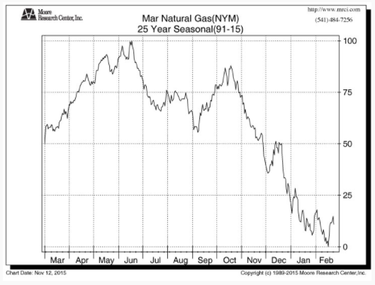

First, we made a plot of the Natural Gas Prices downloaded from Quandl:

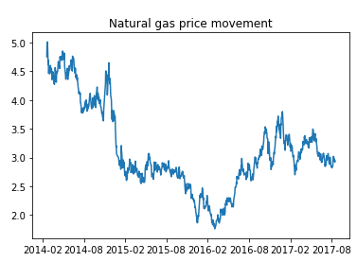

We then detrended the prices and we used the blackman function:

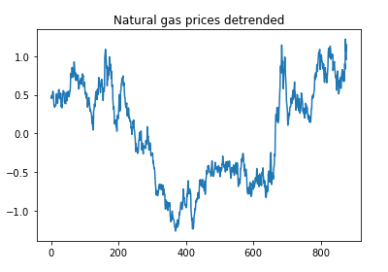 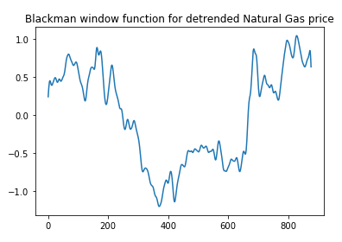

We applied the FFT algorithm:

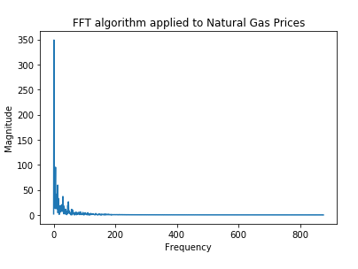

We can notice that the magnitude of the lower frequencies are higher. So we decided to plot a graph considering only the lower frequencies:

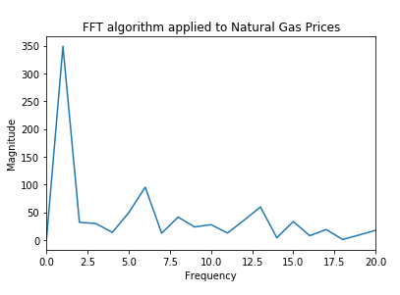

The spike in the frequency of 1 does not mean much to us, at least for trading purposes because it corresponds to all our data. But we have a spike in 6. Considering that the data has approximately 3 years and 6 months (42 months), that means we have a full cycle in 7 months. I am not able to infer a yearly summer / winter pattern considering this cycle. We would need spikes near 3 and 4 to infer a year cycle but we don’t have this in our Discrete Fourier Transform applied to our data.

Nevertheless, we have found some evidence that this classic pattern in Natural Gas has possibly changed since 2008. The Paper: *Seasonal Effects in Natural Gas Prices and the Impact of the Economic Recession* which can be found in (3) claims:

*In this work, we explore how seasonality affects commodity prices, in particular that of natural gas, and assess whether the financial crisis in 2008 has altered these effects. With the aid of principal component analysis, natural gas prices are analysed. We carry out modelling of the seasonal component of the price movements using a two-factor model, focusing on the seasonality and on the impact of the financial crisis, in order to calculate forward curves that allow us to evaluate the views of the market on natural gas prices at specific points in time. With the constructed forward curves, we determine whether utilising seasonal strategies employed in the market has been affected by the financial crisis in 2008 and whether a profit could still be made. We determine that the seasonal component of natural gas prices had been negatively impacted by the financial crisis in 2008.*

One interesting fact is that the paper is from 2013, so our analysis is an out sample from the paper and from the graph provided by optionsellers.com .

1. <https://www.optionsellers.com/natural-gas-special-seasonal-tendencies-tell-put-sellers-to-get-ready/>
2. <https://www.optionsellers.com/natural-gas-special-seasonal-tendencies-tell-put-sellers-to-get-ready/>
3. <https://papers.ssrn.com/sol3/papers.cfm?abstract_id=2198800>